

**Green University of Bangladesh**

**Department of Computer Science and Engineering(CSE)**

**Faculty of Sciences and Engineering**

**Semester: (Spring, Year:2024), B.Sc. in CSE (Day)**

**LAB ASSIGNMENT NO #04**

**Course Title: Data Communication Lab**

**Course Code: CSE 308 Section: 221_D3**

**Lab Experiment Name: Implementing Cyclic Redundancy Check and Parity**

**Checker**

**Student Details**

|  |  |  |
| --- | --- | --- |
| **Name** | | **ID** |
| **1.** | Jahidul Islam | 221002504 |

**Lab Date : 09 – 03 – 2024**

**Submission Date : 22 – 03 – 2024**

**Course Teacher’s Name : Sakhaouth Hossan**

**[For Teachers use only: Don’t Write Anything inside this box]**

|  |
| --- |
| **Lab Report Status**  **Marks: ………………………………… Signature:.....................**  **Comments:.............................................. Date:..............................** |

**1. TITLE OF THE LAB EXPERIMENT:**

**Implementing Cyclic Redundancy Check and Parity Checker**

**2. OBJECTIVES:**

After complementing this lab experiment, we will gain practical knowledge and tthe outcomes of this experiment are

* To implement the parity checker.

**3. PROCEDURE:**

The procedure step by step:

1. **Input**:
   * The program starts by taking input, which is a binary string s.
2. **Initialization**:
   * It initializes a vector data to store characters of the input string s.
   * It initializes an integer variable **strSize** to store the size of the input string s.
3. **Copying String to Vector:**
   * The program then copies each character of the input string s into the vector data.
4. **Counting Ones:**
   * It counts the number of ones in the binary string by iterating through the vector data. This count is stored in the variable **cnt**.
5. **Manipulation Based on Count:**
   * If the count of ones **cnt** is even, it adds a '1' at the end of the binary string.
   * If the count of ones **cnt** is odd, it adds a '0' at the end of the binary string.
6. **Printing Result:**
   * Finally, it prints the modified binary string stored in the vector data.

**4. IMPLEMENTATION**

// Bismillahir Rahmanir Rahim

// jahidulZaid

#include <bits/stdc++.h>

using namespace std;

#define optimize() ios_base::sync_with_stdio(0);cin.tie(0);cout.tie(0);

#define endl '\n'

#define tt long long t; cin >> t;

#define ll long long

#define pb push_back

// #ifdef LOCAL

// #include "debug.h"

// #endif

// #ifdef ONLINE_JUDGE

// #include "debug.h"

// #endif

int main() {

    string s;

    cin >> s;

    int strSize = s.size();

    vector<char>data(strSize);

    for(int i = 0;i<strSize;i++){

        data[i] = s[i];

    }

    int cnt = 0;

    for (int i = 0; i < strSize; i++) {

        if (data[i] == '1') {

            cnt++;

        }

    }

    int c = strSize + 1;

    if (cnt % 2 == 0) {

/*

ths block add 1/0 at the begining of the string.

it needs to declare the vec size +1

        for (int i = c, j = c - 1; i > 0; i--, j--) {

            data[i] = data[j];

        }

*/

        // adds 1 at the end

        data.push_back('1');

    } else {

/*

ths block add 1/0 at the begining of the string.

it needs to declare the vec size +1

        for (int i = c, j = c - 1; i > 0; i--, j--) {

            data[i] = data[j];

        }

*/

        data.push_back('0');

    }

    for(auto x: data){

        cout << x;

    }

    cout<< endl;

    return 0;

}

………….. Continued …………

**5. OUTPUT**

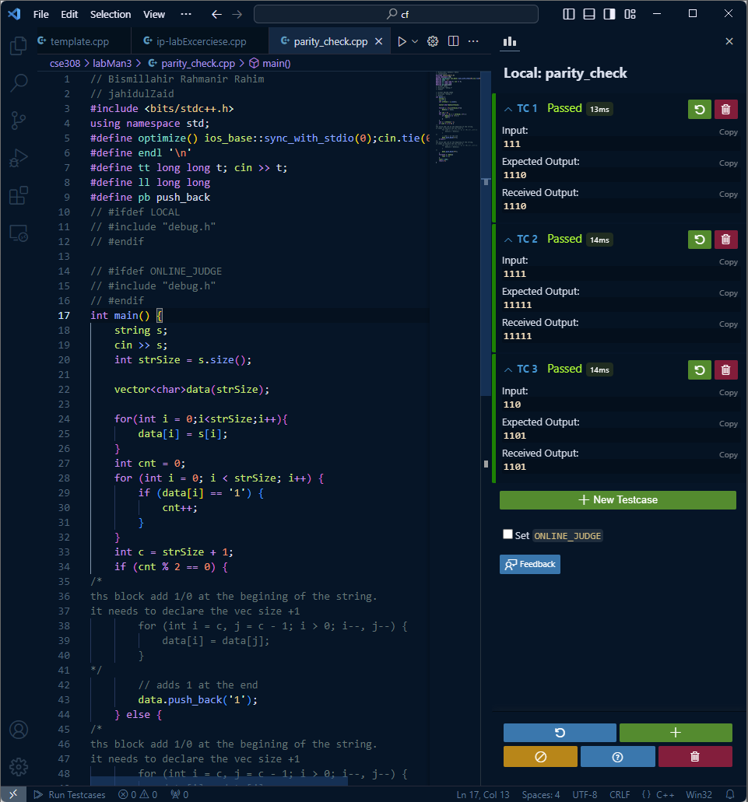

Figure 01: Shows the code and output of this code.

Figure 02: Output of the program.

**6. ANALYSIS AND DISCUSSION:**

* Both blocks of code add '1' or '0' at the beginning of the binary string based on whether the count of ones **cnt** is even or odd.